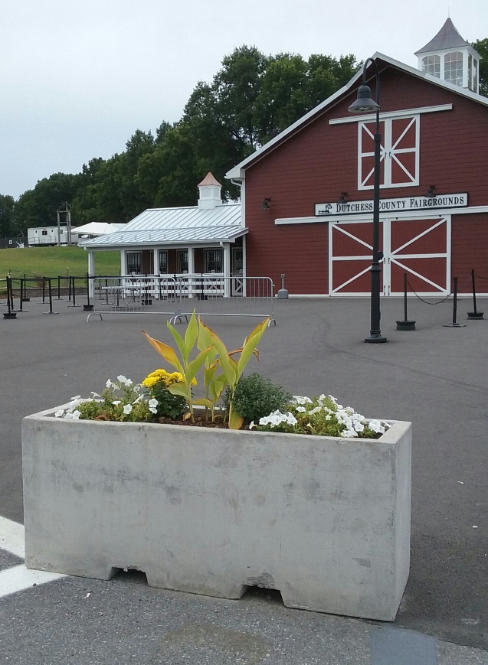

TINTORI CASTINGS CONCRETE PLANTERS

Concrete planters, vases, and urns, can be matched with our standard designs or made custom for your specific project specs. From the Rhinebeck Fair barrier planters shown here, to the delicate wood pattern planter boxes for a town house entryway. We can work with your specific site needs. Concrete has its own look, feel, texture, and weight, with a beautiful natural aging quality. Delicate pieces have interior supports. Ask us how our custom concrete can fit your project design.

